**What Is A Tab?**

Tabs in Salesforce help users view the information at a glance. It displays the data of objects and otherweb content in the application.

There are mainly 4 types of tabs:

(A)**Standard Object Tabs:** Standard object tabs display data related to standard objects

(B)**Custom Object Tabs:** Custom object tabs displays data related to custom objects.

(C)**Web Tabs:** Web Tabs display any external Web-based application or Web page in a Salesforce tabs.

(D)**Visualforce Tabs:** Visualforce Tabs display data from a Visualforce Page.

**Creation Of Semester Tab :**

* To create custom object, first go to home page then enter Tabs in the Quick Find box and choose Tabs.
* Click New under Custom Object Tabs and Select Semester as the Object. Choose an icon for Tab Style.
* Leave all defaults as is. Click Next, Next, and Save.

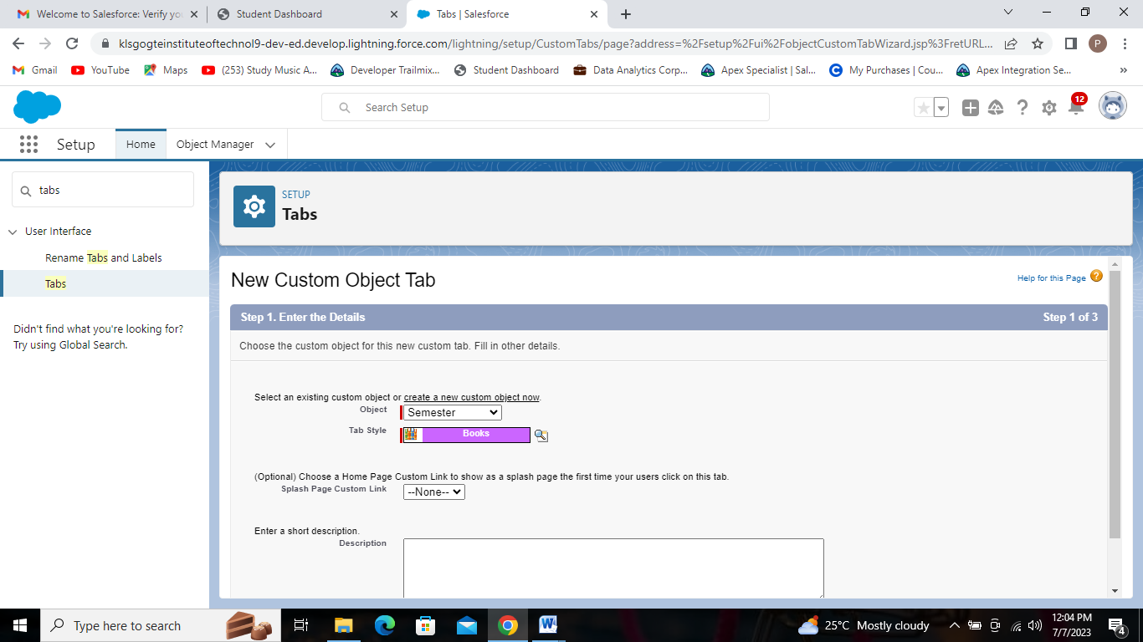

Semester Custom Tab.

* Create Tabs for all Custom Objects, including Candidate, Course Details, Lecturer Details, and Internal Results.

**Creation Of Candidate Tab :**

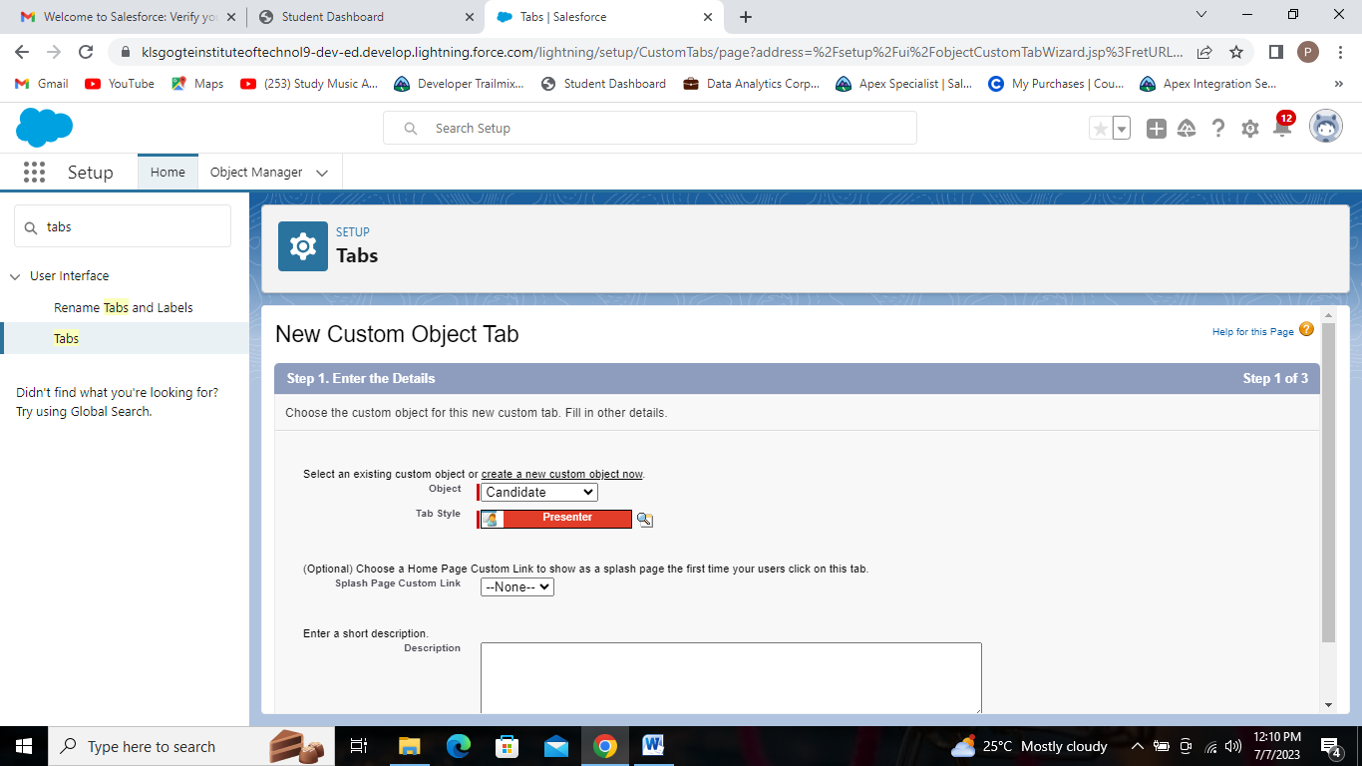

Candidate Custom Tab.

**Creation Of Course Details Tab :**

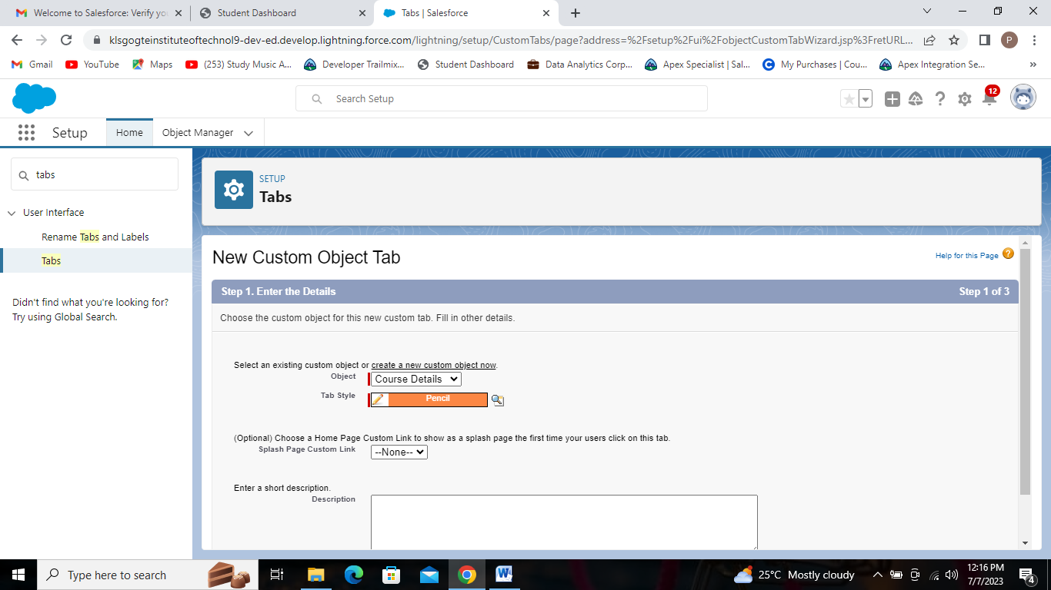

Course Details Custom Tab.

**Creation Of Lecturer Details Tab :**

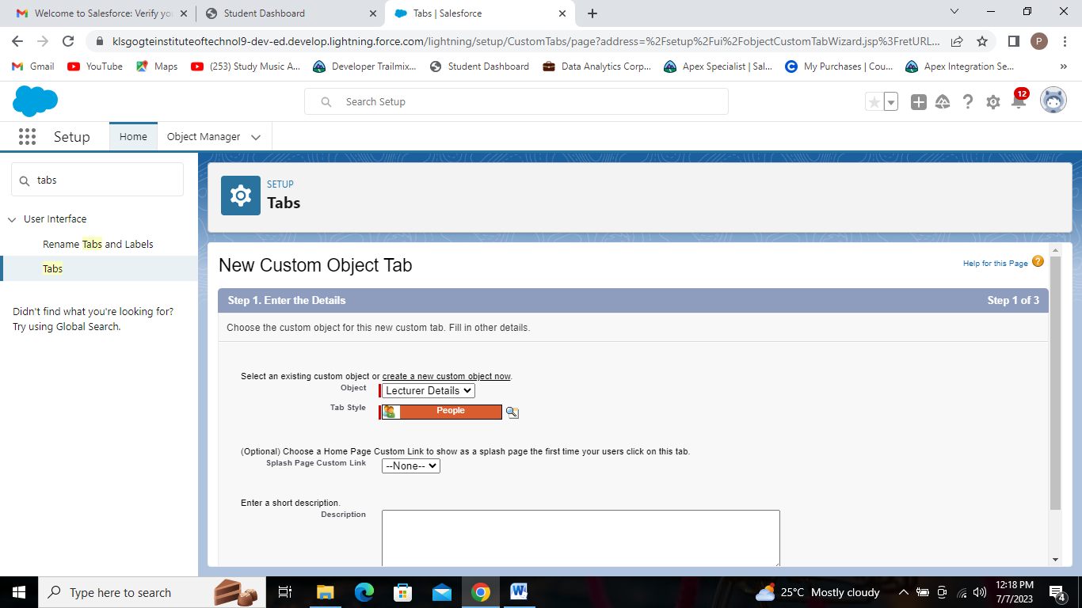

Lecturer Details Custom Tab.

**Creation Of Internal results Tab :**

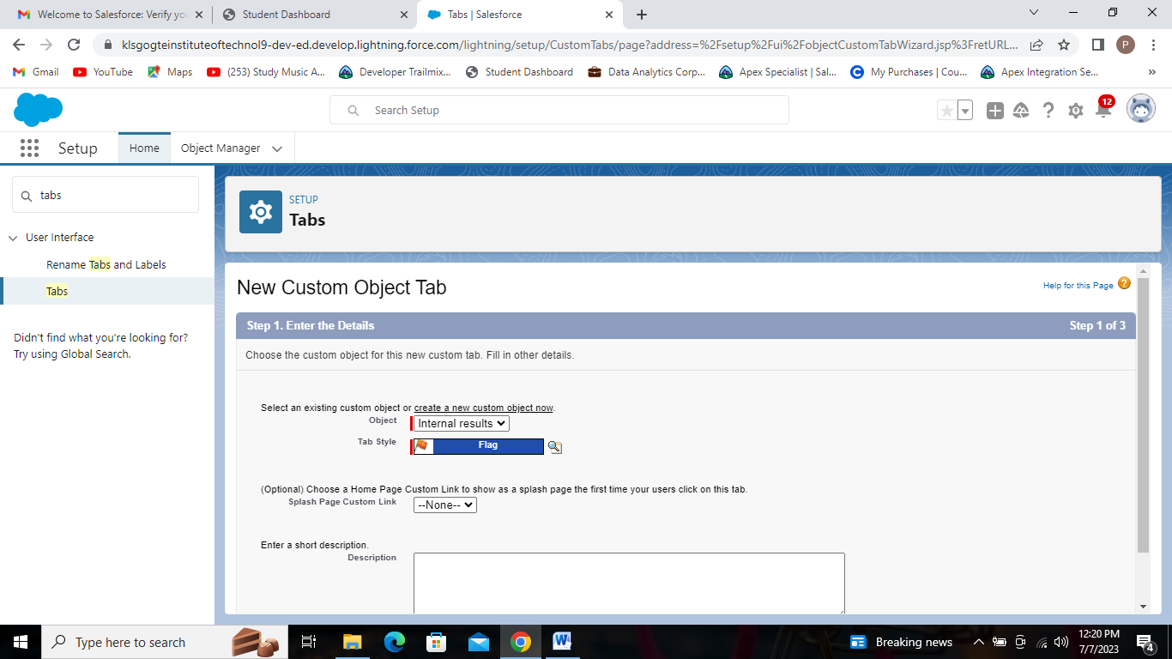

Internal results Custom Tab.

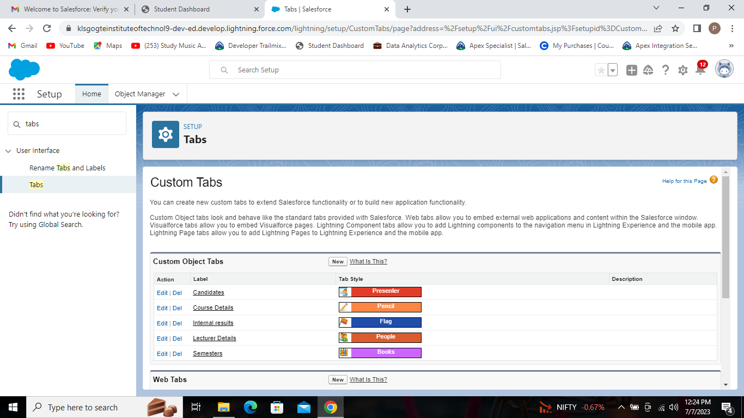

The five custom tabs we created.